

223849-EPP-1-2014-1-GR-EPPKA3-ECHE

UNIVERSITY OF PELOPONNESE

*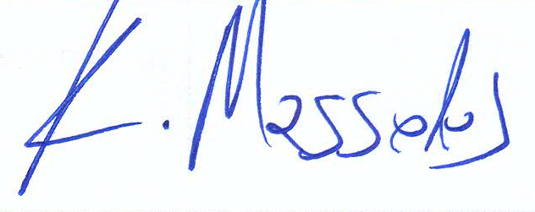*

PROF. KONSTANTINOS MASSELOS, RECTOR

Legal representative

G TRIPOLI03